CNNP Skill-1
G. Neha
2520030409
Step-1,2:
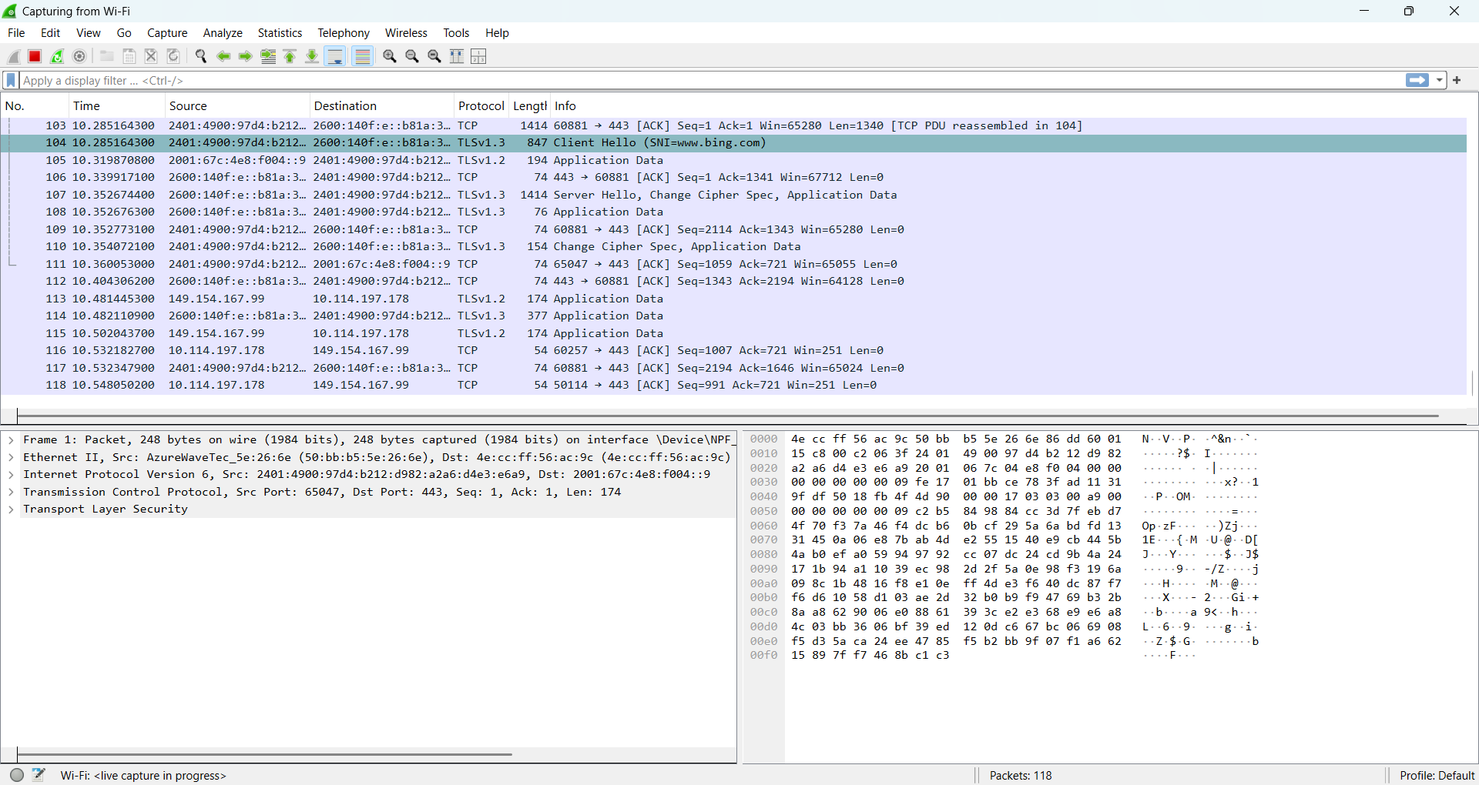
Step-3:
TCP:
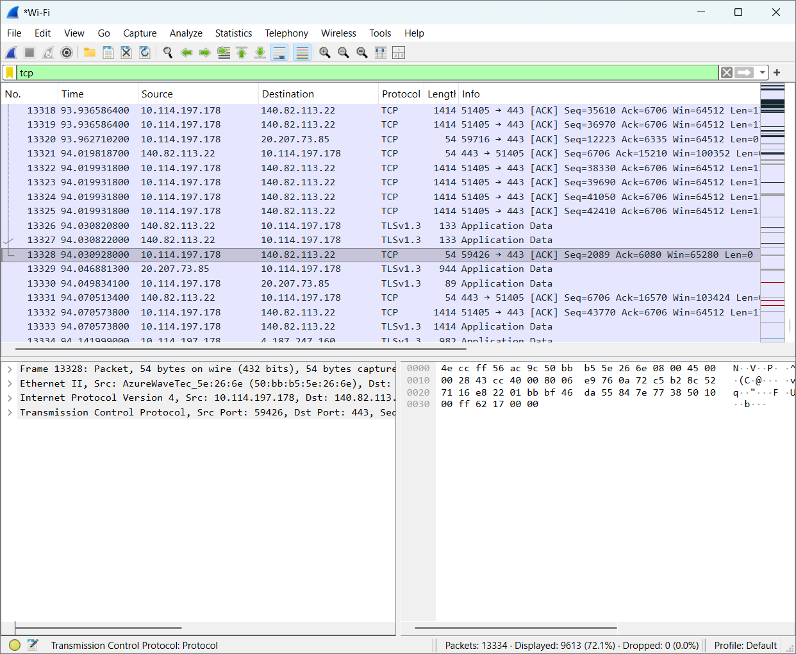
UDP:
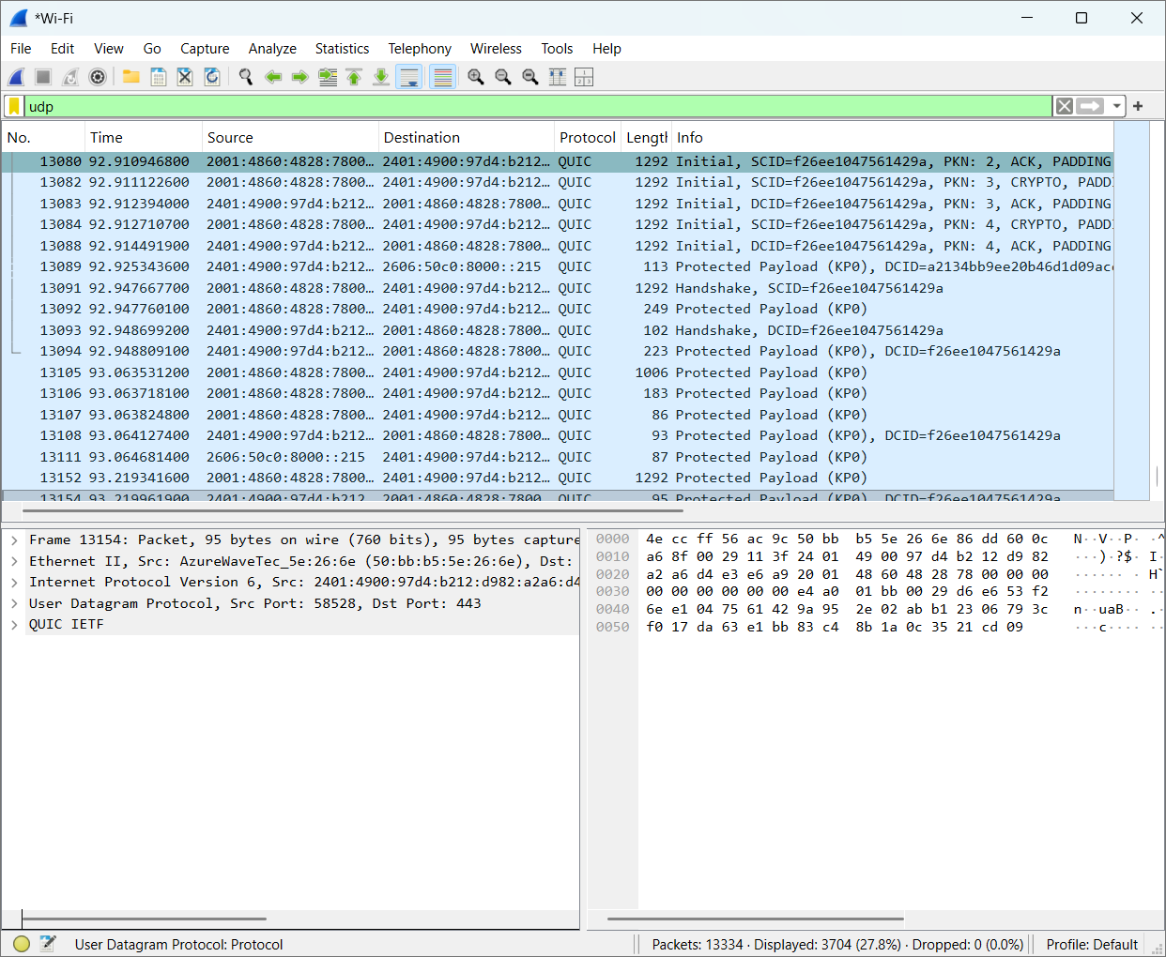

Frame:
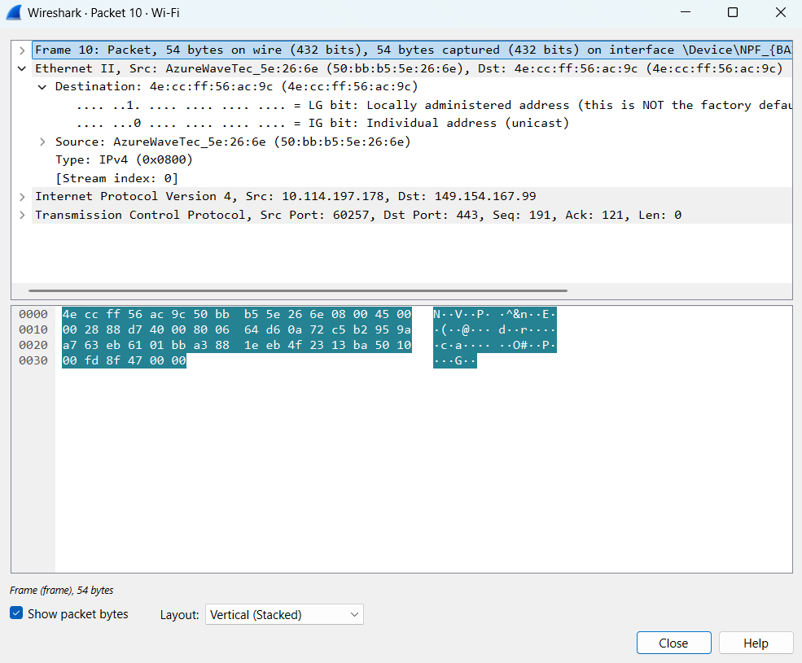

Ethernet:
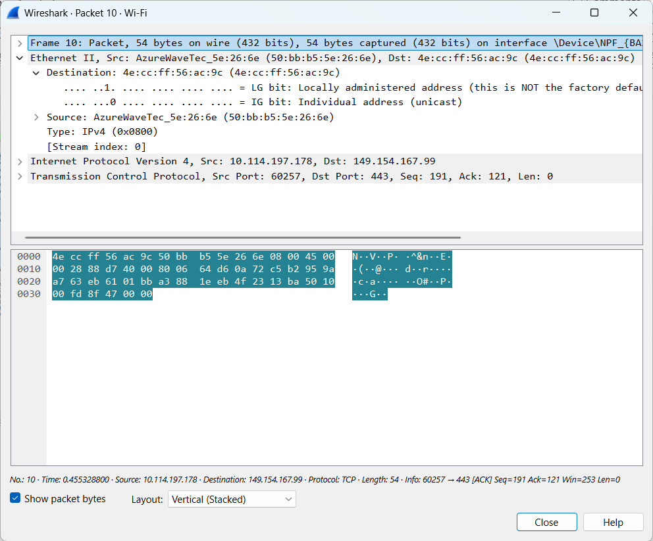
- Frame: 54 bytes
- Ethernet II: present
- IPv4: present
- TCP: present
- Source IP: 10.114.197.178
- Destination IP: 149.154.167.99
- Source port: 60257
- Destination port: 443
Udp:
1.Frame:
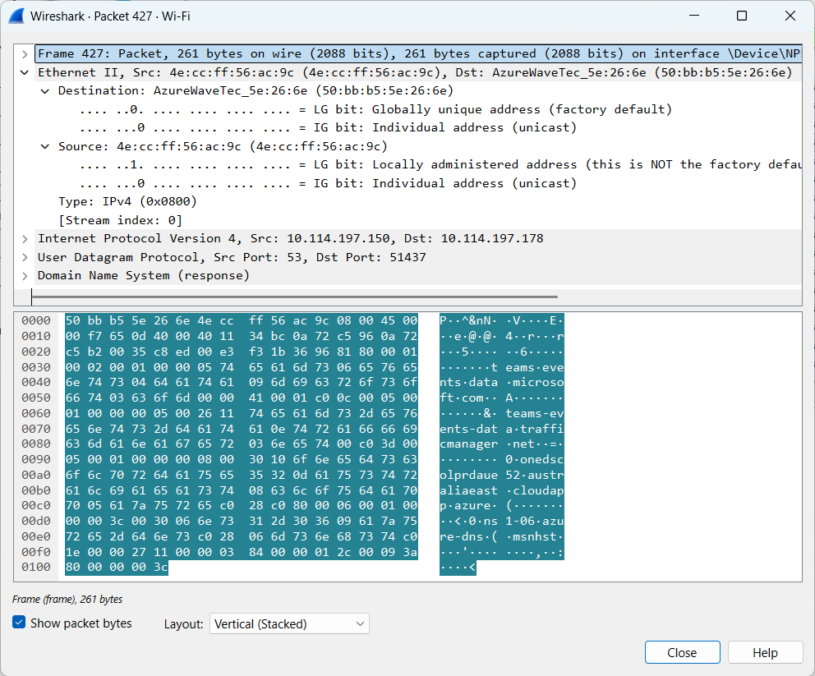
2.Ethernet:
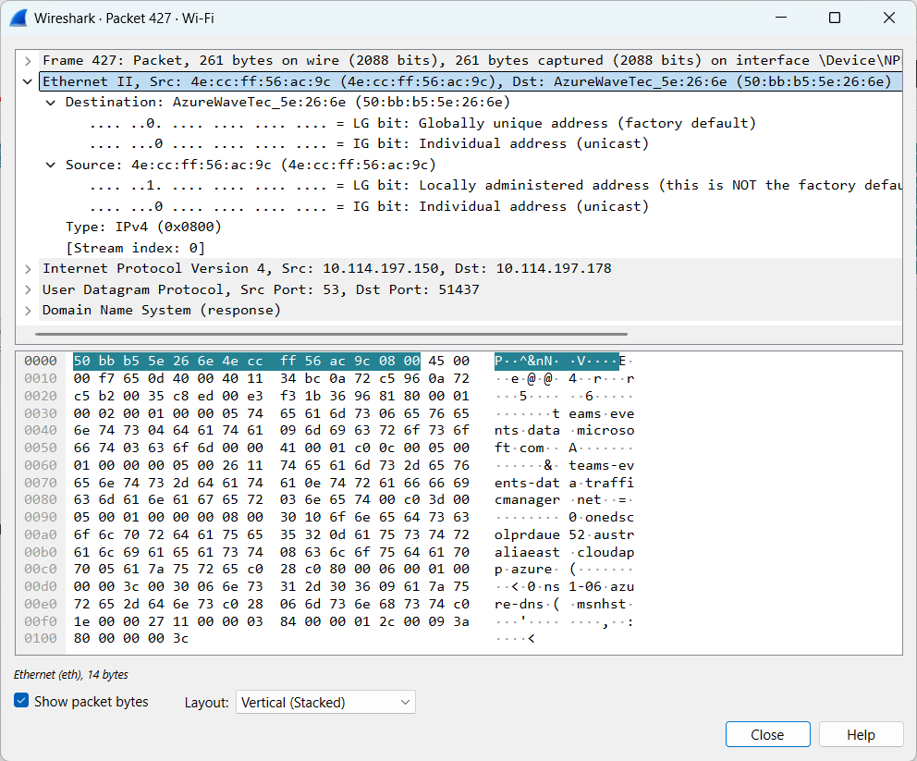
- Frame: 261 bytes
- Ethernet II: Present
- IPv4: Present
- UDP: Present
- Source IP: 10.114.197.150
- Destination IP: 10.114.197.178
- Source port: 53
- Destination port: 51437
Step-6:
Header Overhead = Ethernet + IPv4 + UDP
= 14 + 20 + 8

Payload Efficiency:
219/261 * 100 = 83.91%
Parameter | TCP packet | UDP packet
Frame length | 54 | 261
Ethernet Header Length | 14 | 14
IP Header Length | 20 | 20
Transport Header Length | 20 | 8
IP Total Length | 40 | 247
Transport Segment Length | 20 | 227
Payload Length | 0 | 219

